**Task 3 – DIG200: Fintech Innovations**

**Total Points: 100**

**Important Instructions:**

1) Answer every question (all 4 questions). Each question can be answered well within 300-400 words. However, as writing styles differ, there are no penalties for exceeding the word-count limit.

2) This is an individual assessment. All submissions will be very carefully looked at for any signs of collusion/plagiarism. Please make sure that you work individually and write everything in your own words.

3) Be concise and write clearly. Cite your sources.

4) You can download the questions and work offline.

5) Make sure that you upload your answers before the deadline

**(Module 3 and Module 5) Question 1 - CBDCs**

Read Gearin, P. (2022), “How Cloud Could Power Australia’s Digital Currency by 2025”, Available at: <https://www.themandarin.com.au/197756-digital-currency-cloud/>

After reading the above article, prepare a response to the following:

Suppose Australia launches a CBDC version of the Australian dollar. Illustrate the potential benefits and risks with the help of AD/AS framework. Briefly explain. Draw diagrams as needed to support your answer (25)

**Benefits of a CBDC Version With the Australian Dollar:**

1. Enhanced Security and Stability: CBDCs would provide a more secure and stable digital currency compared to cryptocurrencies, as they are issued and regulated by Australia’s central bank, ensuring higher security standards.
2. Direct Access to the RBA: Australians with CBDC accounts will have direct access to the RBA, allowing for cheaper, safer, and faster transfers by eliminating intermediaries. This will streamline money flow and enhance overall economic efficiency.
3. Better Economic Management: The central bank can monitor CBDC transactions, providing valuable data that enables improved management of inflation, interest rates, and other macroeconomic factors in Australia (NTT Data, 2024).

**Risks of a CBDC Version With the Australian Dollar:**

1. Privacy Concerns: CBDCs may raise privacy issues, as the central bank could potentially monitor every transaction conducted using them, this would only happen if privacy controls weren’t put in place accordingly by the RBA
2. Reduced Role of Traditional Banks: With direct access to the RBA, CBDCs could diminish the reliance on traditional financial intermediaries, such as banks, for everyday transactions.
3. Potential Bank Runs: In extreme situations, like a financial crisis, there may be a significant surge in withdrawals from commercial banks as individuals opt to store their funds in CBDCs backed by the central bank.

**AD/AS Framework in Relation to CBDCs:**

Aggregate Demand (AD) represents the total demand for domestically produced goods, including consumer goods, services, and capital goods. It is expressed as C + I + G + (X − M), where C is consumption, I is investment, G is government spending, X is exports, and M is imports. Together, these components represent Gross Domestic Product (GDP) (Kling, 2023).

Aggregate Supply (AS) can be classified as short-run (SRAS) or long-run (LRAS). SRAS illustrates the relationship between the GDP and current price levels, while LRAS indicates the economy's potential output when unemployment is zero and the workforce is operating at full capacity (IG, 2024).

In terms of CBDCs' impact on AD, they are likely to increase AD by enhancing consumption, investment, and exports due to improved accessibility and efficiency. Meanwhile, CBDCs could also boost AS by increasing productivity and reducing transaction costs, thereby removing existing bottlenecks. However, risks such as financial disintermediation and cybersecurity threats could negatively impact AS if users become wary.

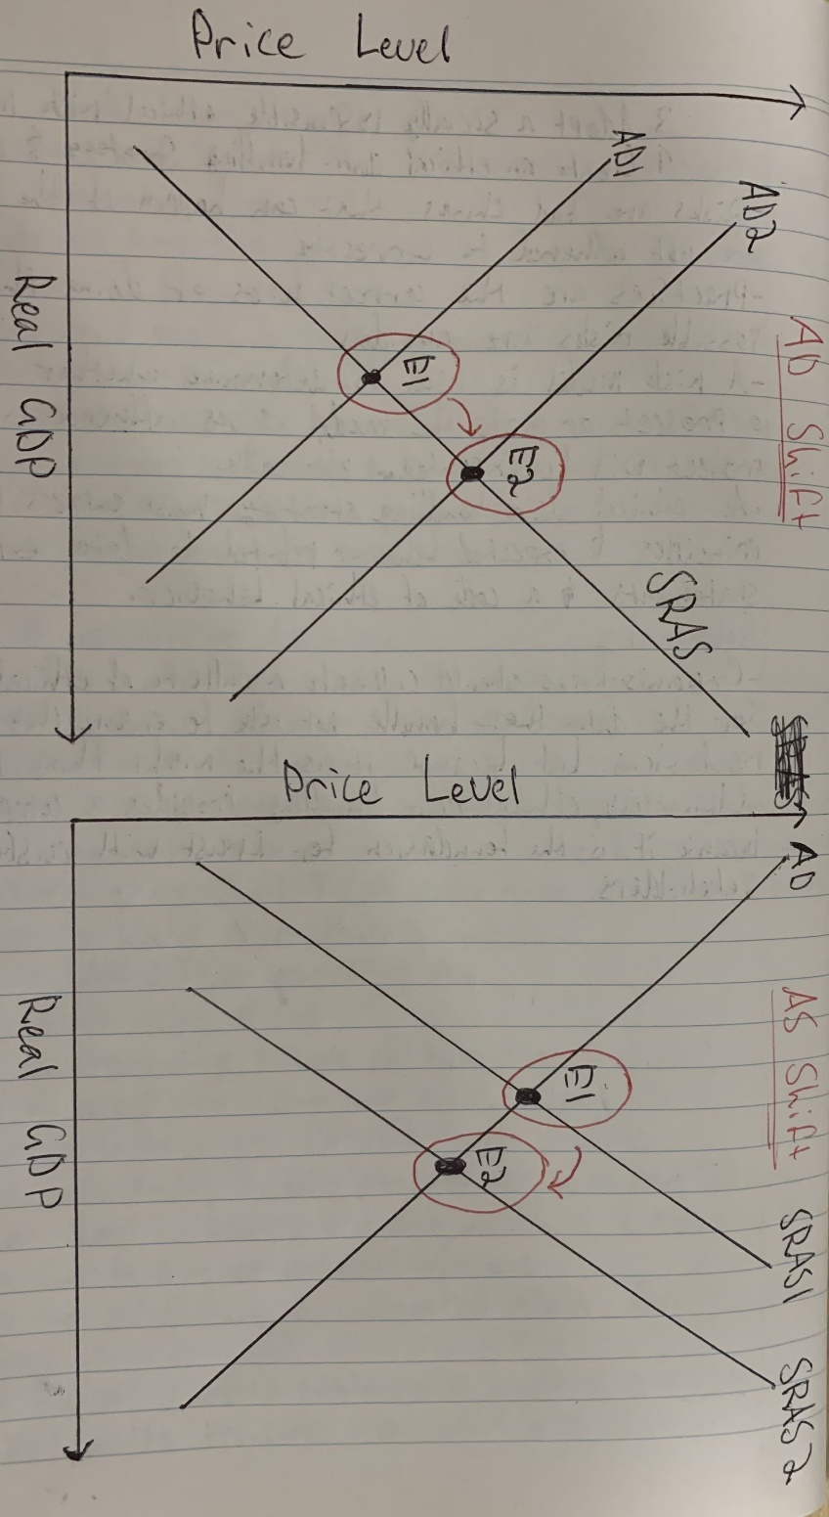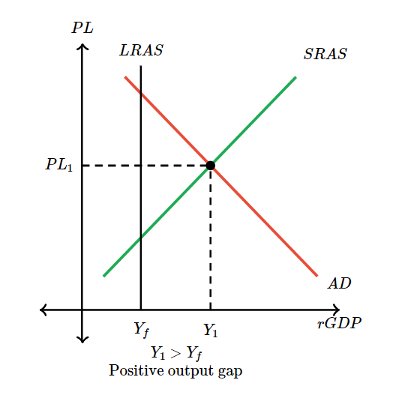**AD/AS Diagram:**

(Khan Academy, 2019)

**AD Shift and AS Shift Diagrams:**

**(Module 1 and Module 5) Question 2 – The Impact of Bitcoins**

Read Cho, R. (2021), “Bitcoin’s Impact on Climate and the Environment”, Available at: <https://news.climate.columbia.edu/2021/09/20/bitcoins-impacts-on-climate-and-the-environment/>

After reading the above article, prepare a response to the following:

By using the Aggregate Demand-Aggregate Supply framework (AD/AS framework), show the likely impact of creation and popularity of Bitcoins. Briefly explain. Draw diagrams as needed to support your answer (25)

**Impact Regarding AD:**

In regard to the creation and popularity of Bitcoin, AD may be influenced through the adoption of consumer and investor behaviour.

* Alternative investment asset: As Bitcoin’s popularity continues to rise, demand for the cryptocurrency as an investment asset is also growing rapidly. This increase in demand attracts more individuals and institutions to invest in Bitcoin, potentially diverting funds away from traditional investment avenues. As a result, the availability of funds for conventional investments in sectors directly contributing to AD can decrease. This shift could lead to a reduction in AD for the economy, as resources are allocated more so to the digital currency market rather than traditional investment markets which associate much more directly towards AD.
* Wealth and consumption: As Bitcoin holders see the value of their cryptocurrency investments rise, they may be more inclined to spend or invest additional funds, potentially leading to a short-term increase in AD. However, due to Bitcoin’s high volatility, this effect can quickly reverse. If Bitcoin’s value declines, investors may hold onto their money or withdraw it from the market, leading to a short-term decrease in AD. Therefore, while Bitcoin’s rising value can temporarily boost AD, its market fluctuations can also dampen consumption and investment in the short run (World Economic Forum, 2022).

**Impact Regarding AS:**

Bitcoin’s affect towards AS is similar to its affect to AD, which can be directly associated with customer and investor behaviour.

* Energy demand and production costs: Bitcoin mining, a process essential to obtaining the volatile asset, is highly energy intensive. As Bitcoin’s popularity grows, the resulting surge in energy consumption drives up energy prices, in turn increasing production costs across various sectors. This rise in energy demand and associated costs will shift AS leftward in the long run, contributing to higher price levels for goods and services. In the context of Bitcoin, these factors may indirectly raise the cryptocurrency’s value as mining costs and operational demands continue to escalate.
* Digital transaction costs: Bitcoin and its underlying blockchain technology are driving the widespread adoption of digital transactions. This technology has the potential to reduce transaction costs in financial and e-commerce sectors, enhancing efficiency and productivity. With lower transaction costs, these sectors could experience increased economic output, potentially shifting AS rightward in the long run.

**Supporting Diagrams:**

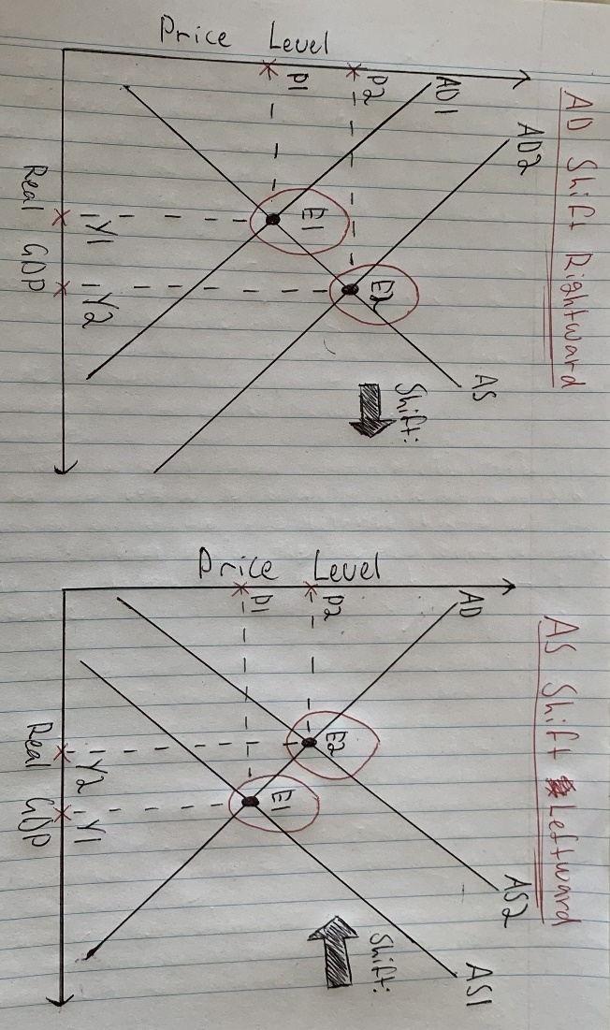From the supporting diagrams I’ve drawn (AD Shift Rightward and AD Shift Leftward), in the scenario where AD continues to shift right and AS continues to shift left, the economy has the potential to experience pressure towards inflation but with relatively low impact regarding a long-term output.

**(Module 2 and Module 6) Question 3 – Payment System Innovations and the Role of Challenger Banks/Neo Banks**

1. After watching the video here: <https://www.youtube.com/watch?v=IPxQQNyCxas>

Prepare a response to the following: What particular value do Ubank and ING (Australian Challenger Banks) add to customers in the “card processing network”? (Feel free to explore additional sources such as the websites of these banks). (12.5)

Ubank and ING add significant value to customers in the “card processing network” in the following ways (Ubank, n.d.) (ING, 2024):

* Lower fees and competitive rates; As challenger banks without a physical branch presence, Ubank and ING can offer lower fees on card transactions compared to traditional banks. These cost savings benefit frequent card users and customers making international payments, providing a valuable alternative for those seeking lower fees and competitive rates.
* Enhanced digital experience; With a focus on a seamless digital experience, Ubank and ING prioritise features like real-time transaction notifications, easy card management, and digital wallet integration. These features enhance convenience and give customers greater control over their transactions.
* Rewards and cashback programs; Ubank and ING offer unique perks not typically available at traditional banks, such as cashback on purchases, competitive interest rates on savings when minimum spending thresholds are met, and no international transaction fees. These incentives expand card usage within their networks, adding extra value for customers while increasing engagement in the card processing network.
* High-security standards; Advanced security is essential for neobanks, Ubank and ING ensure customer protection through features like multi-factor authentication and biometric login options. By investing in modern cybersecurity measures, both banks safeguard customer data and build trust for digital transactions.

1. Discuss the key similarities and differences between Ubank and ING. (Feel free to explore additional sources such as the websites of these banks) (12.5)

**Similarities:**

* Digital first; Ubank and ING make an emphasis towards app-based banking through providing innovative interfaces for users, with features such as budgeting tools, card management, and real-time notifications. It is also important to note that both neobanks support digital wallets, focusing towards a convenient and mobile-driven banking experience with no physical branch presence.
* Low fees; Both banks have a strong reputation in terms of minimal fees, particularly regarding transactions. Ubank and ING don’t charge fees for international transactions or monthly account fees, this makes both neobanks a go to service for customers looking towards affordable, everyday banking solutions.
* High security; Advanced security measures are taken place for Ubank and ING, one security measure is multi-factor authentication. This measure is used to protect users’ digital banking activities online, reinforcing both neobanks’ appeal to tech-savvy users prioritising secure online banking.

(Ubank, n.d.) (ING, 2024).

**Differences:**

* Unique savings and rewards; ING offers unique features like cashback incentives, competitive savings interest rates, and perks tied to meeting monthly spending requirements. Ubank, however, focuses more on straightforward savings benefits, allowing customers to earn bonus interest on accounts without minimum spending, which simplifies savings growth for users primarily interested in building their savings.
* Platform experience; Ubank is designed as an app-centric platform, providing features such as transaction categorisation and the ability to connect external bank accounts for a unified view. ING, in contrast, offers a more developed web platform in addition to its mobile app, enabling users to access services seamlessly across both desktop and mobile. This approach makes ING more versatile for users who prefer a mix of mobile and desktop options, while Ubank prioritises a streamlined mobile-first experience.
* Accessibility and support for customers; Ubank, as part of NAB, operates with a lighter support structure and is sometimes considered NAB’s budget-friendly alternative. Meanwhile, ING has a more robust, well-developed customer support system, owing to its larger international presence and extensive experience in digital banking. This often translates to enhanced support options and services for ING’s customer base.

(Ubank, n.d.) (ING, 2024).

**(Module 7, Module 8, Module 9, and Module 10) Question 4 - Securitization, Shadow Banking, and the impact of Fintech Innovators such as Kabbage and Square Capital**

1. How does securitization matter for the traditional banking sector? How does it matter for the shadow banking sector? Briefly explain. (12.5)

**Traditional Banking Sector:**

Securitization can be described as the financial alchemy of using non-tradeable assets, pooling them together, to then sell tradeable shares from that pool to interested investors (Chen, 2023). In a broader layout, (Chen, 2023) states that securitization takes any asset such as cryptocurrencies for crypto exchange-traded funds or even properties and related assets for real estate investment trusts, selling the securities related to these trusts. For traditional banks, securitization transforms illiquid loans (e.g., mortgages) into liquid assets, enhancing liquidity and increasing lending capacity by freeing up capital (Loutskina, 2011). Additionally, it helps banks transfer credit risks to investors, diversifying exposure, providing an extra revenue stream from structuring and issuing fees. Using these functions, securitization strengthens banks' balance sheets, supports financial stability, and fuels further lending opportunities.

**Shadow Banking Sector:**

Shadow banking refers to financial activities similar to those in traditional banking, like lending and liquidity management, but performed by institutions outside regular banking regulations (Pozsar et al., 2013). Shadow banks perform credit, maturity, and liquidity transformations but lack access to public liquidity sources and government-backed protections. This under-regulated sector uses complex processes, such as securitization, to enhance liquidity, allowing these institutions to fund loans with wholesale sources instead of customer deposits (Goddard & Wilson, 2016). Many shadow banks operate with high leverage and limited transparency, avoiding the oversight applied to licensed banks. By bundling loans into securities for investors rather than holding them, shadow banks increase their lending capacity but depend heavily on external funding and securitization, which adds systemic risk to financial stability (Pozsar et al., 2013).

1. Briefly discuss the impact of innovative fintech lenders such as Kabbage and Square Capital on the macroeconomy. (12.5)

**Impact on the Macroeconomy by Kabbage:**

Kabbage is an online financial service that offers small businesses rapid access to funding by utilising real-time data to streamline the credit approval process. Now owned by American Express, Kabbage enhances support for small businesses with flexible financial solutions and efficient capital access (United Capital Source, 2024).

In terms of its macroeconomic impact, Kabbage improves credit availability for small businesses, particularly in underserved communities. By automating and optimising the loan approval process, Kabbage enables quick funding, allowing businesses to better manage cash flow, invest in growth, and maintain operations. This approach underscores a significant shift in how businesses secure financing, emphasising the role of fintech services over traditional banking methods in the macroeconomy and influencing AD/AS positively.

**Impact on the Macroeconomy by Square Capital:**

Square leverages real-time revenue data to provide lending solutions for small and medium-sized businesses that struggle to secure traditional bank loans due to insufficient collateral. This data-driven approach led to the creation of Square Capital, which assesses credit risks using information from its payment processing systems. A significant advantage of Square Capital is its flexible repayment options, allowing businesses to pay back loans based on their current revenue streams (Canvas, 2024).

By offering accessible financing, Square Capital plays a vital role in the macroeconomy, supporting underserved businesses in the fintech market. This support fosters economic growth and stability by enabling job creation and workforce retention during downturns. Moreover, facilitating cash flow management allows these businesses to invest in expansion and innovation, further enhancing their contributions to the economy and positively influencing the AD/AS framework.

**References:**

* Canvas. (2024). Canvas login | instructure. Usc.edu.au. https://learn.usc.edu.au/courses/27681/pages/module-2-section-1-how-block-square-makes-money?module_item_id=621130
* Chen, J. (2023, September 29). Securitization: How debt makes you money. Investopedia. https://www.investopedia.com/terms/s/securitization.asp
* Goddard, J., & Wilson, J. (2016). Banking. Google Books. https://books.google.com.au/books?id=Anh4DQAAQBAJ&pg=PA43&source=gbs_toc_r&cad=2#v=onepage&q&f=false
* IG. (2024). Aggregate supply definition. IG. https://www.ig.com/uk/glossary-trading-terms/aggregate-supply-definition
* ING. (2024). About us. Www.ing.com.au. https://www.ing.com.au/about-us.html
* Khan Academy. (2019). The aggregate demand-aggregate supply (AD-AS) model. Khan Academy. https://www.khanacademy.org/economics-finance-domain/ap-macroeconomics/ap-macro-resources-and-exam-preparation/every-graph-used-in-ap-macroeconomics/a/the-aggregate-demand-aggregate-supply-ad-as-model
* Loutskina, E. (2011). The role of securitization in bank liquidity and funding management. Journal of Financial Economics, 100(3), 663–684. https://doi.org/10.1016/j.jfineco.2011.02.005
* NTT Data. (2024). Top 10 advantages and disadvantages of central bank digital currencies (CBDC) | NTT DATA payment service. NTT DATA Payment Services. https://www.nttdatapay.com/blog/advantages-disadvantages-of-central-bank-digital-currencies/
* Pozsar, Z., Adrian, T., Ashcraft, A., & Boesky, H. (2013). Shadow Banking. In Federal Reserve Bank of New York (p. 16). https://www.newyorkfed.org/medialibrary/media/research/epr/2013/0713adri.pd
* S. Kling, A. (2023). Aggregate demand. Econlib. https://www.econlib.org/library/Topics/Details/aggregatedemand.html
* Ubank. (n.d.). Why ubank? About Us - ubank. Www.ubank.com.au. Retrieved October 31, 2024, from https://www.ubank.com.au/why-ubank
* United Capital Source. (2024). Kabbage funding review. United Capital Source. https://www.unitedcapitalsource.com/business-loans/lender-reviews/kabbage-funding-review/
* World Economic Forum. (2022). The Macroeconomic Impact of Cryptocurrency and Stablecoins. https://www3.weforum.org/docs/WEF_The_Macroeconomic_Impact_of_Cryptocurrency_and_Stablecoins_2022.pdf

*****End of Assignment*****